SVMHA Coach and Manager Registration Guidelines
- Click on the following link to register as Bench staff for SVMHA. You will not be placed on a roster if this has not been completed. You will be brough to the following page. Click on “Register Now”.
https://page.spordle.com/st-vital-minor-hockey
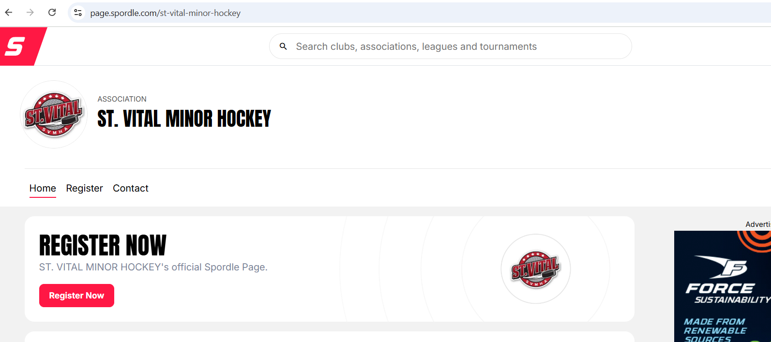

- Scroll Down and click on “Bench Staff (Coach, Manager, Safety)
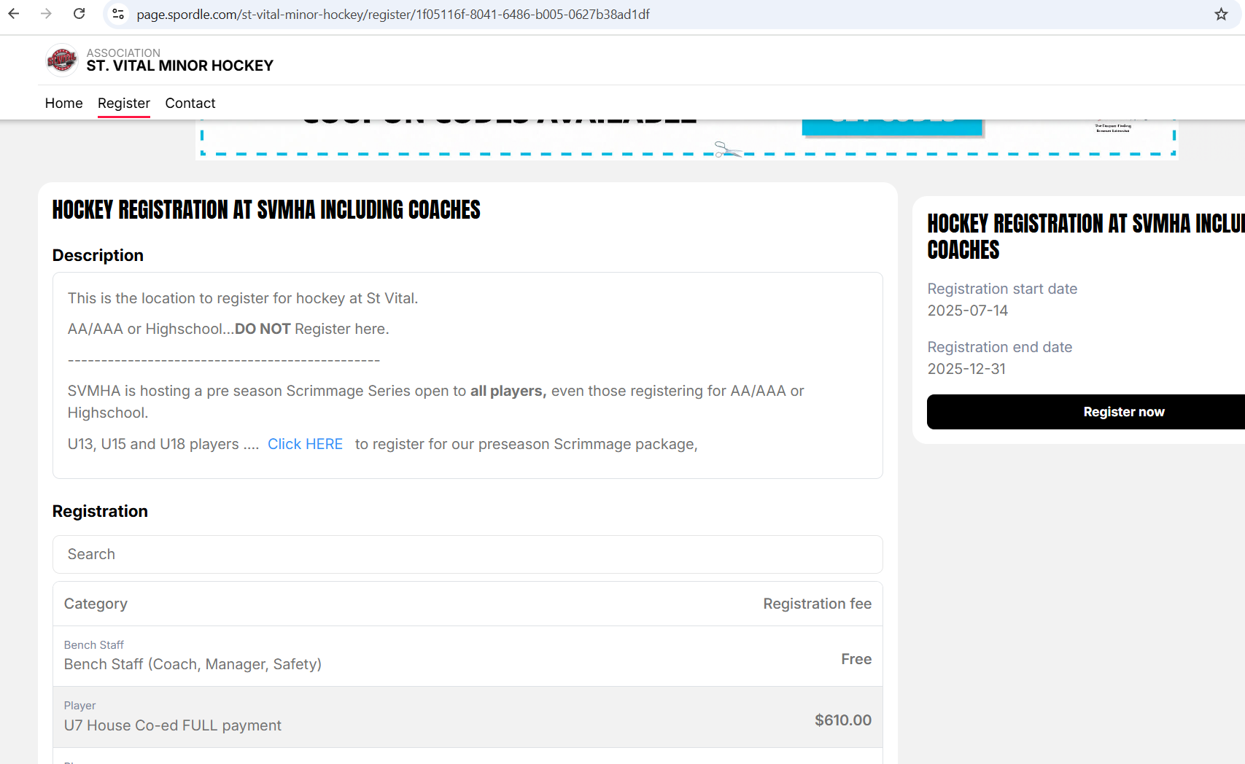

- “Click on Register now”
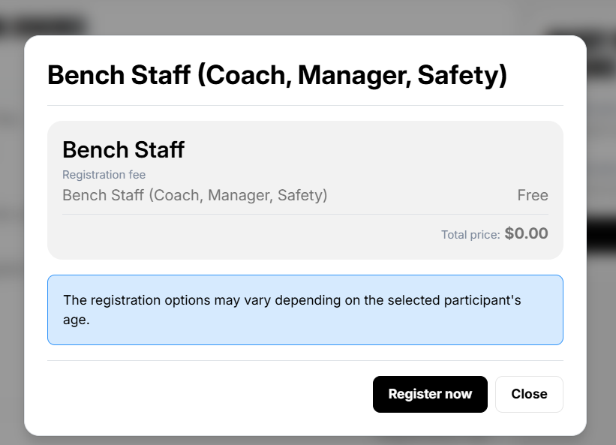

- Sign in to your HCR profile.
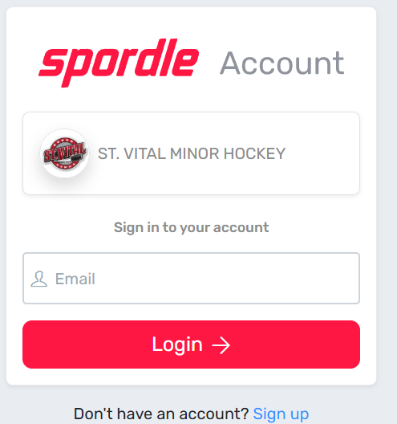
- Once you are logged in it will bring you to a list of participants under your profile. Click on your name.
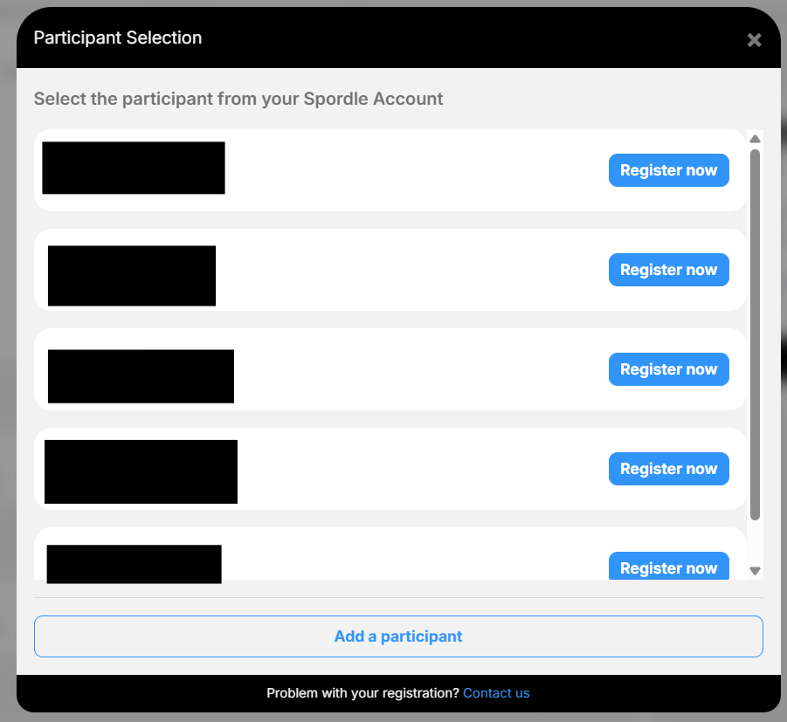

- Select “Bench Staff (Coach, Manager, Safety)” then click “Next”
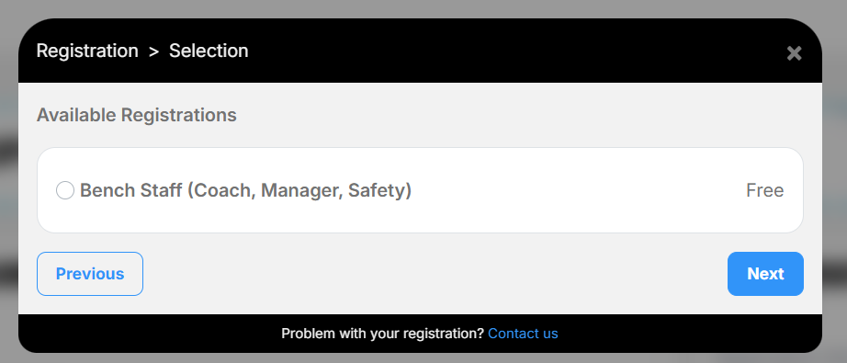

- Click on Fill out Questionnaire.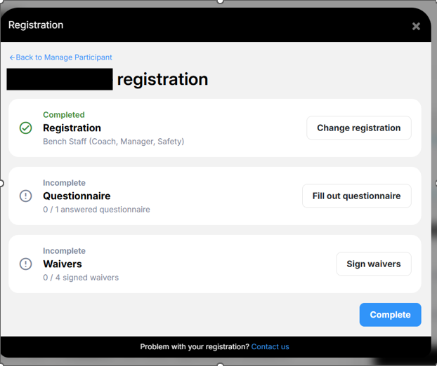
- Fill out Questionnaire as required.
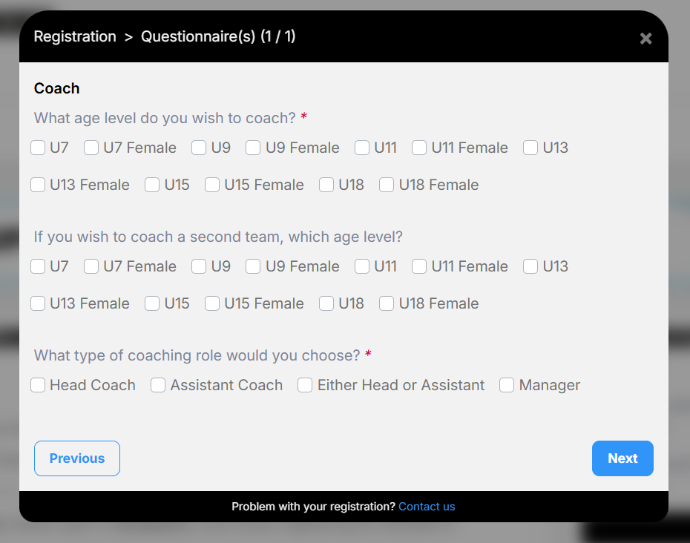

- Click on Sign Waivers.
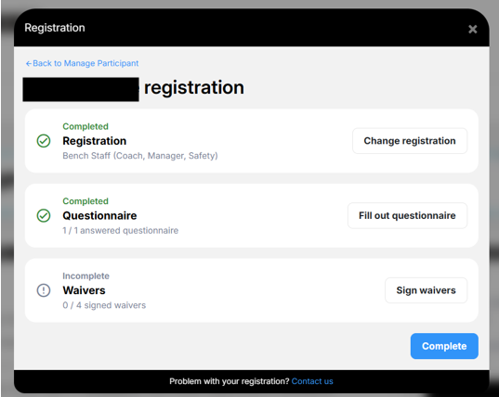
- Read the waiver and Click on “I agree” (if you do) Click “Next”.
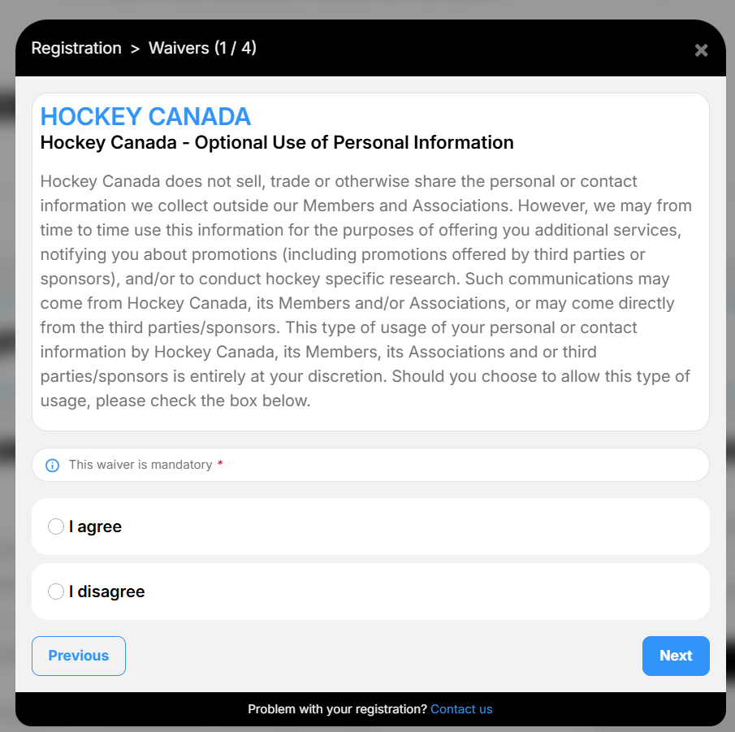

- Read the waiver and click on "I have read and accept the waiver”. Click “Next”.
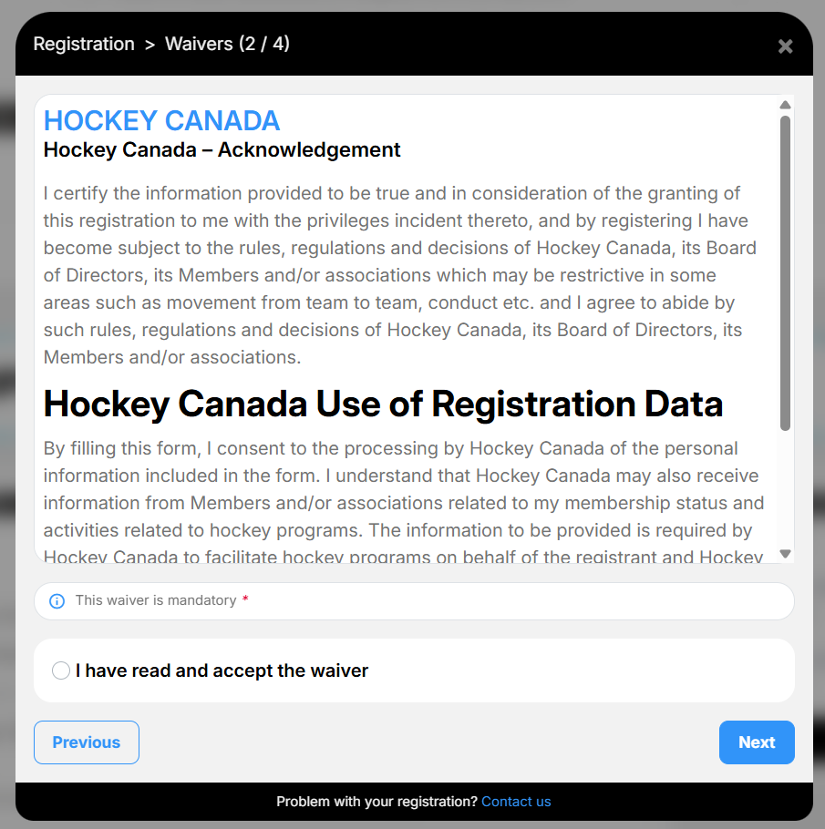

- Read the waiver and click on “I confirm” then click on “Next”.
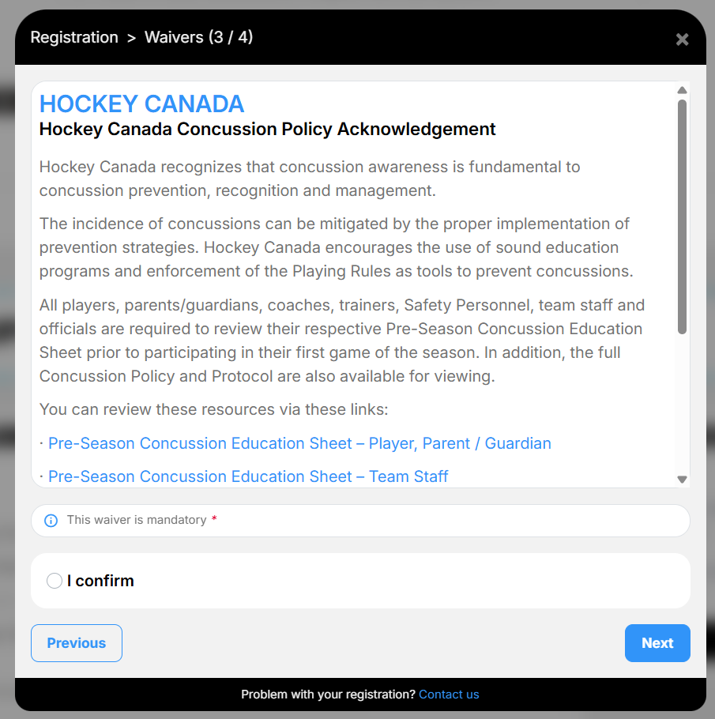
- Read the waiver and click on “I have read and accept the waiver”.
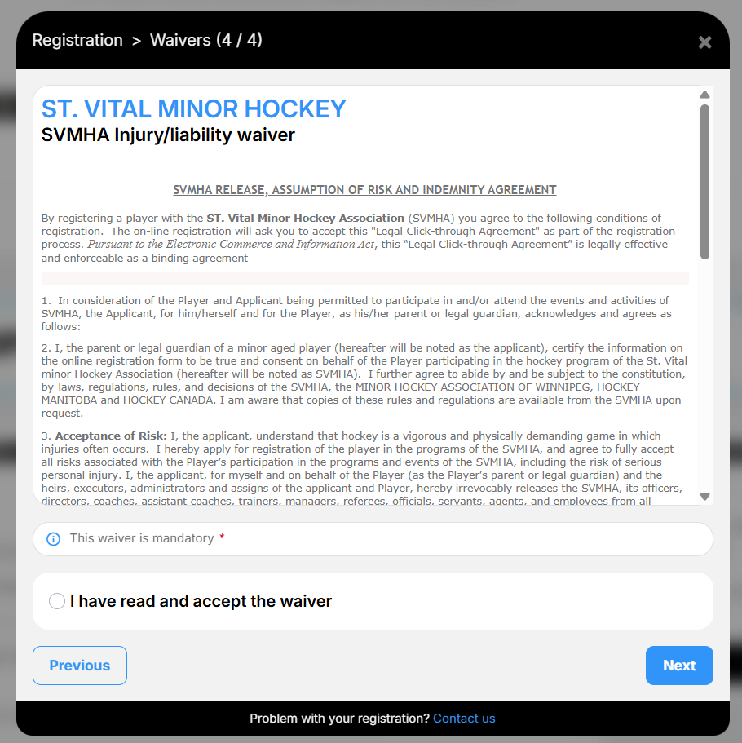

- Lick on “Complete”
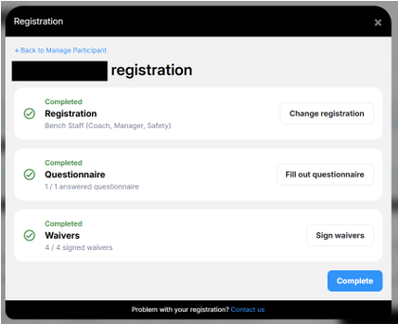

- Click on “Checkout”.
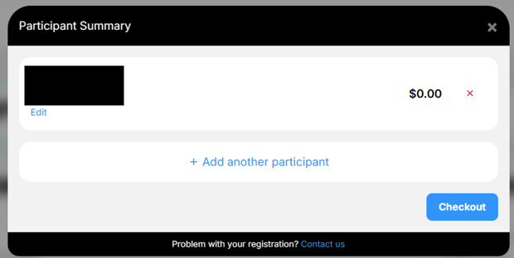

- Click on “Next”.
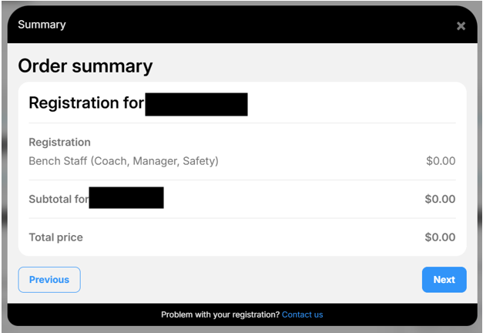

- Read Payment Terms and Conditions (there is no fee to register as Bench Staff). Click on “I have read and accept the terms and conditions”. Click on “Next”.
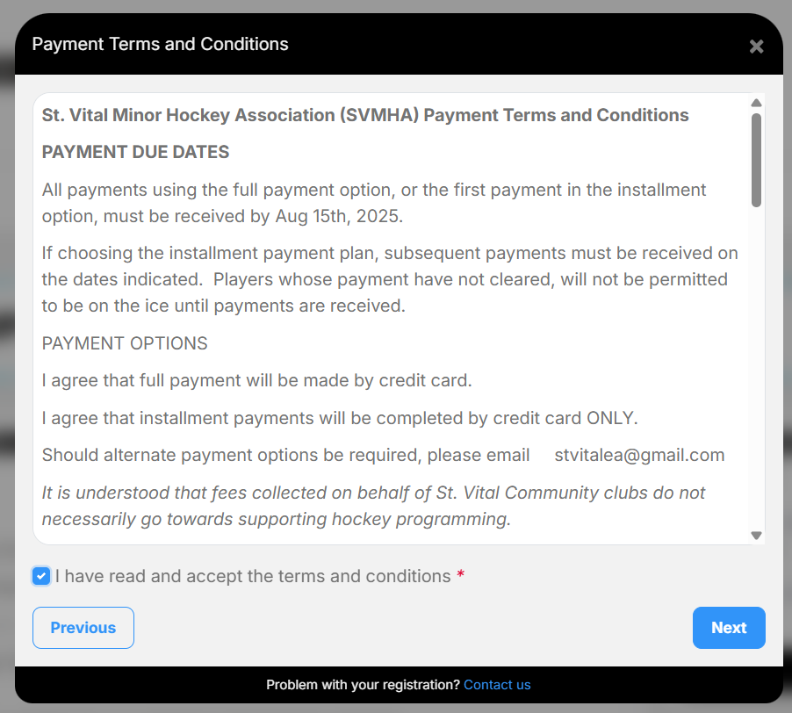

- Click on “Complete”.
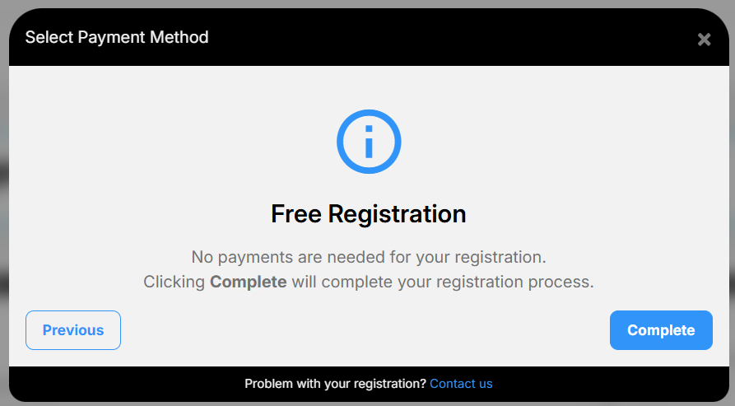

- You will receive a thank you notice.
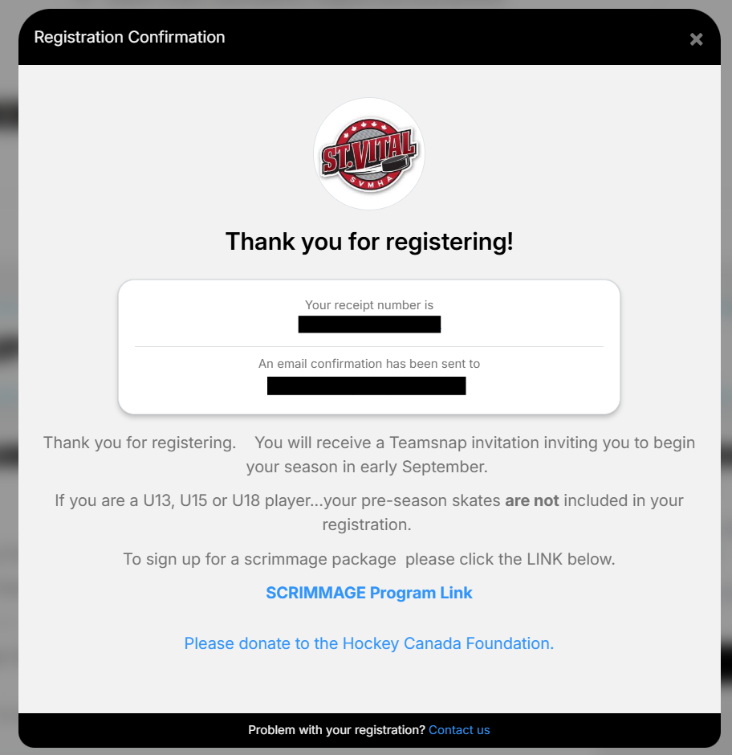

- You are now registered to coach for SVMHA.

