Finding Your HCR Number
- Click on the following link to get to Hockey Canada Registration login page.
https://myaccount.spordle.com/login?lang=en&referrer=https%3A%2F%2Fregister.hockeycanada.ca%2Fhome
Fill in your email address associated to your HCR account. This should be the same account you used to register your child.

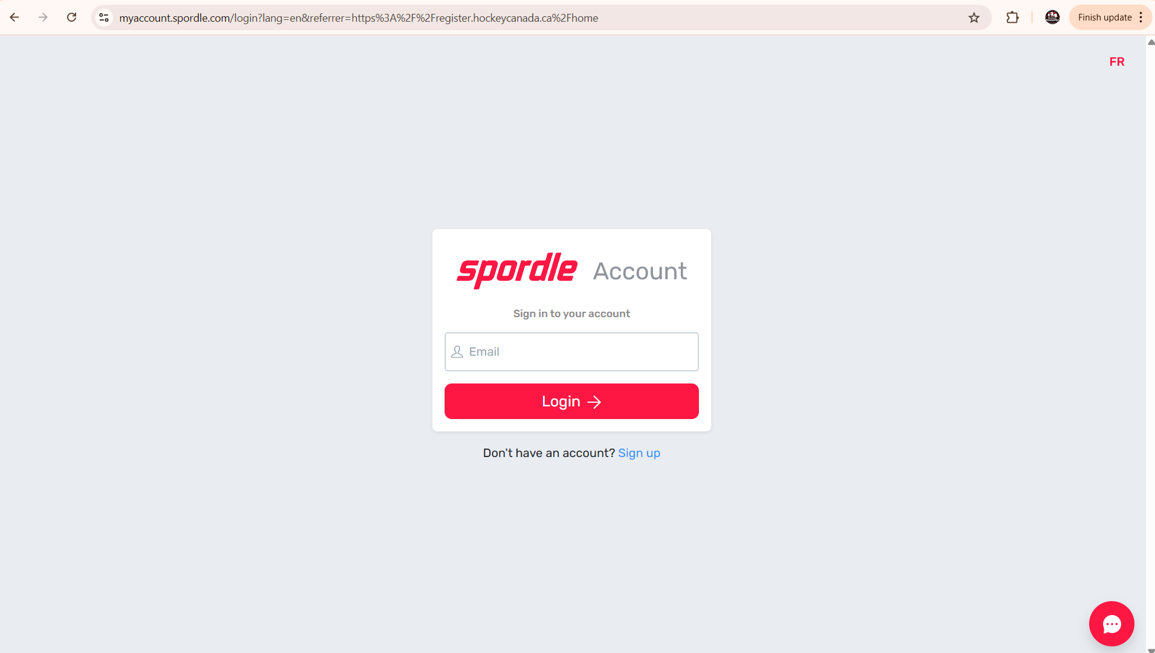
- Enter your password.
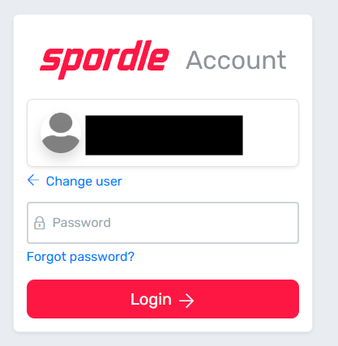
- Click on members.
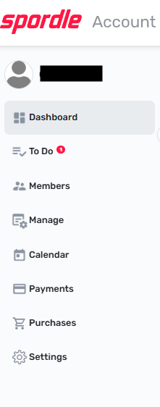

- Ensure you are on your profile not your child’s. All profiles will be listed along the top of the page in circles with all members initials. Click on your initials.
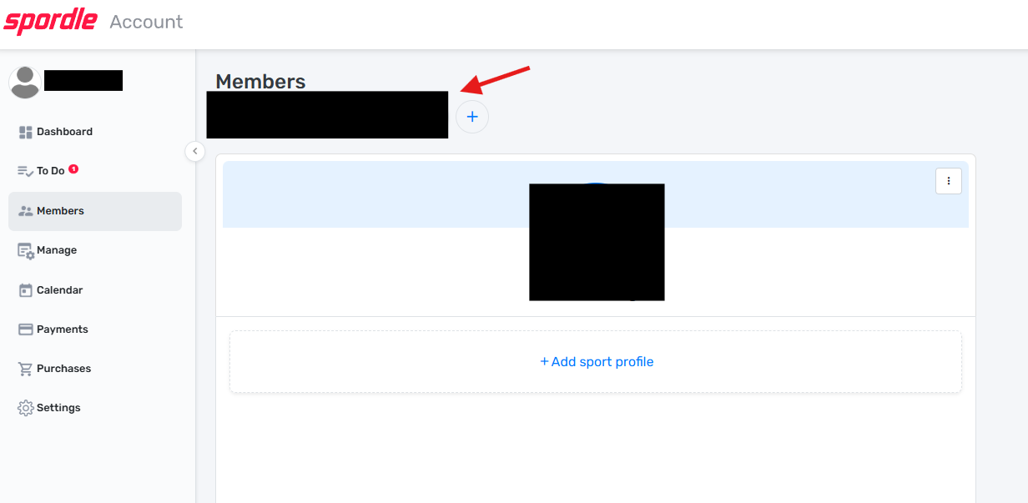
- Your HCR number is listed here under your home association.
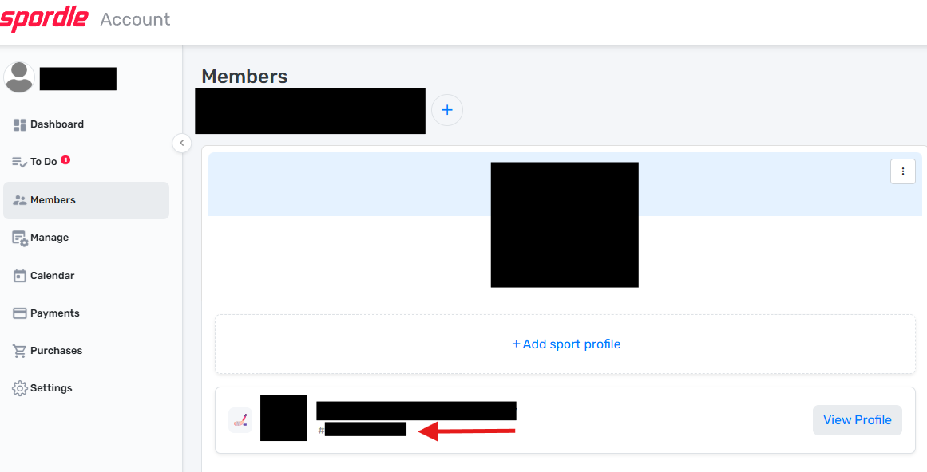

- Or you can also click on “View Profile”. You can see your HCR number where the red arrow is pointing.
