Hockey Winnipeg – Parent Program

User Instructions for Respect in Sport for Parents

The following brief instructions are provided to assist with accessing and advancing through Respect in Sport.

Registering for Respect in Sport-Parent program: https://hmbparent.respectgroupinc.com

- Click on the link or button displayed to access the program. By default the system will load in English.
- 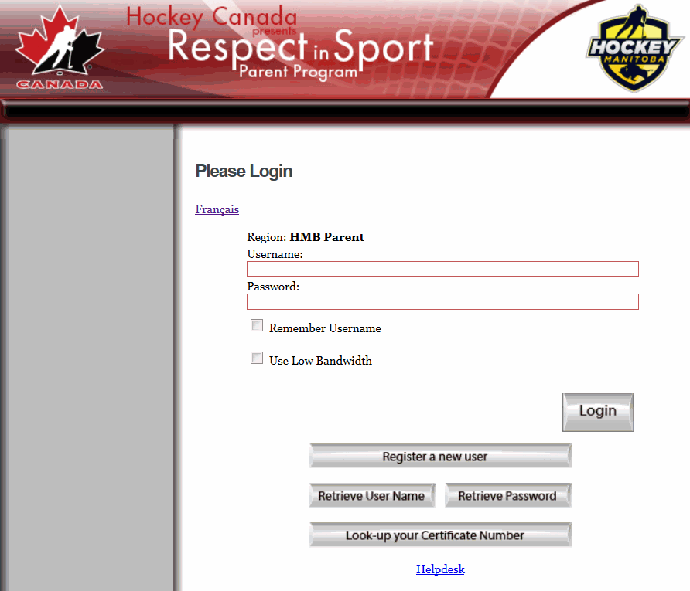 Click the word “Français” to translate the page if necessary.
- Select “Register a New User”
- Create a username and password for your-self in the appropriate fields. Respect Group Inc. recommends using an email as a username as this is generally unique to an individual and not easily forgotten.
- Complete all fields. Any fields identified with a red X is a mandatory field and must be completed. Other fields are considered optional but may be requested by your organization.
- Any field with a “?” in a circle beside the red X has a tool tip. If you run your mouse over the tool tip, more information about that field will be displayed.
- Review and accept the Respect Group Inc. privacy policy.
- Click Submit at the bottom of the page and you will be prompted to associate your child/children to your profile.
- This step is critical for the recognition of your certification by your organization.
- Enter the proper child information in the Child Management Page, then click on No Further Children to Add when done.
- NOTE: you can add other children later with the Profile option.
- You will then be prompted for payment through a secure PayPal transaction.
- Once completed, click on the language of your choice, then on Parent Program Content in the left hand side menu.
- Enjoy Respect in sport.

Re-accessing Respect in Sport
- Click on the link or button displayed to access the program. By default the system will load in English. Click the word “Français” to translate the page if necessary.
- Enter the username and password you entered while registering for the program.
- The completed lessons will be indicated with a checkmark; you can then continue to the next uncompleted lesson.
- You can re-access any completed lessons.
- Handouts are always accessible from the program slides or from the Handouts menu at left.

